Chandigarh University



**Project Report**

**BACHELOR OF COMPUTER APPLICATION**

**ELECTRONICS SALES MANAGEMENT SYSTEM**

***Submitted by:***

***Chandan kumar Chaurasia***

***22BCA10789***

***Sec:7_B***

# TABLE OF CONTENTS

**CHAPTER 1. INTRODUCTION** ............................................................

1.1. Introduction to Electronics Sales Management System .................. 1.2. Each Selling Product Specification ................................................

**CHAPTER 2. Design And Implementation** ............................................

2.1. Sales Table OF The Electronics ..................................................... 2.2. Queries Implemented with Case Study ...........................................

**CHAPTER 3. Conclusion** ........................................................................

3.1. Summary From the Sales Table ....................................................

# INTRODUCTION

## Electronics Sales Management System

The **Electronics Sales Management** table serves as a comprehensive record of product performance across various categories in the current financial year. It contains detailed information about each product, including its **name and associated category**—such as televisions, laptops, audio systems, and home appliances—allowing for organized tracking and easy analysis. A significant

aspect of the table is that it captures **seasonal sales data**, clearly distinguishing between **sales during the winter and summer seasons**. This breakdown provides valuable insights into customer buying behavior and product demand patterns throughout the year. Additionally, the table includes a column summarizing the **total sales for each product** in the **current year**, enabling management to quickly identify top-performing products and those that may need promotional support. By integrating product categorization, seasonal trends, and annual sales performance, the Electronics Sales Management table acts as a powerful decision-making tool for optimizing inventory, marketing strategies, and business growth.

**Product Specifications in the table:**

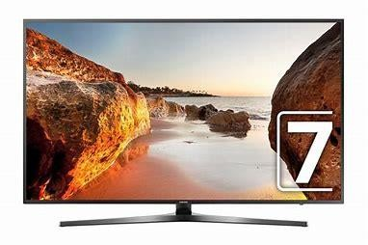

### 1. SAMSUNG LED TV: The **Samsung**

**LED TV** offers a vivid and immersive viewing experience with options ranging from Full HD to 4K UHD resolution. It comes equipped with Smart TV features such as built-in streaming apps, screen mirroring,

voice assistant support, and multiple connectivity options like HDMI, USB, and Wi-Fi, making it a perfect choice for modern home entertainment.

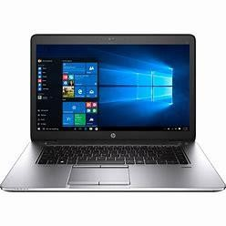

1. H.P LAPTOP:The **H.P Laptop** is designed for performance and productivity, featuring Intel or AMD processors, 8GB RAM (expandable), and SSD or HDD storage options. It typically runs on Windows 11 and includes a Full HD display, long battery life, and essential ports for connectivity, making it suitable for students, professionals, and everyday users.

1. JBL SPEAKERS: The **JBL Speakers** are compact, wireless Bluetooth speakers known for delivering rich sound quality with deep bass. They are built to be portable and durable, often featuring water resistance (IPX7), voice assistant integration, long battery life, and easy pairing with devices, making them ideal for both indoor and outdoor listening.

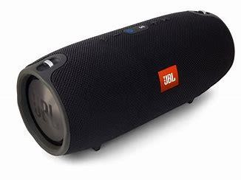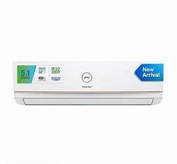

1. GODREJ A.C.: The **Air Conditioner** in the catalog typically includes energyefficient split or window units with inverter technology. These models come in 1 to 2-ton capacities and feature fast cooling, copper condenser coils, and modes like turbo cooling and sleep mode, offering comfort during high temperatures with lower power consumption.

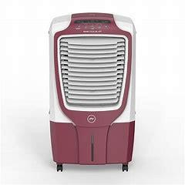

1. GODREJ COOLERS: The **Godrej Coolers** are robust air-cooling units suited for summer, offering large tank capacities (30L–55L), powerful airflow, and honeycomb cooling pads. They are designed for desert or personal use, and many models come with inverter compatibility, ice chambers, and remote-control functionality.

1. HAVEL’S FAN: The **Havel’s Fan** combines modern design with efficient airflow. Available in ceiling, pedestal, or table variants, they feature aerodynamic blades, high-speed motors, and low noise levels. Some models offer remote control operation and energy-saving performance, ensuring comfort and style in any room.

### 7. SAMSUNG MOBILE

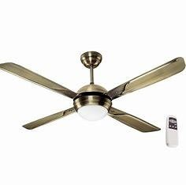

PHONE: The **Samsung Mobile** range includes smartphones with AMOLED displays, highresolution cameras, and longlasting batteries. Powered by Xenos or Snapdragon processors and running on Android with One UI, these phones offer smooth multitasking, secure biometric features, and support for 4G or 5G connectivity.

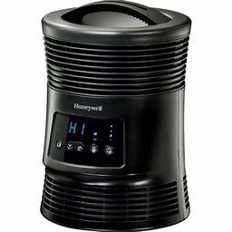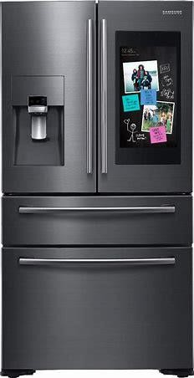

### 8. HONEYWELL HEATER: The

**Honeywell Heater** is a reliable heating appliance for winter, offering ceramic or fan-based heating with adjustable temperature settings. It includes essential safety features like tip-over and overheat protection and provides quick and consistent warmth in compact, portable designs.

### 9. SAMSUNG FRIDGE: The **Samsung**

**Fridge** is built with modern refrigeration technology, offering frost-free operation, digital inverter compressors, and spacious compartments. Features like convertible freezer modes, stabilizer-free operation, and smart cooling ensure food stays fresh while saving energy throughout the year.

**IMPLEMENTATION**

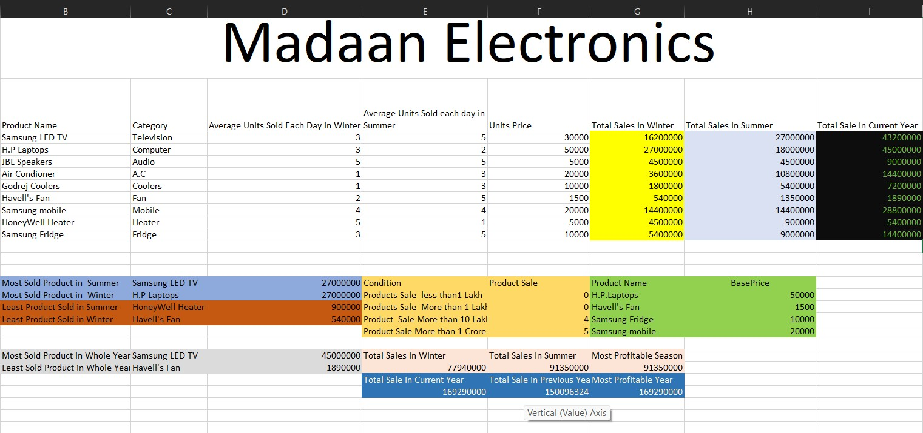

Sales Table of Madaan Electronics:

Description(What it consist):

* Product Name
* Category
* Average Unit Sold in Winter
* Average Unit Sold in Summer
* Unit Price
* Total Sales in Winter
* Total Sales in Summer • Total Sales of Current Year
* Total Sales of Previous Year

Case Study:

1)Calculate the total sales of each product in Winter.

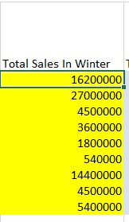Solution: Query which will be used is:

=((D9*F9) *30) *6

2)Calculate the total sales of each product in Summer

Solution: Query which will be used is:

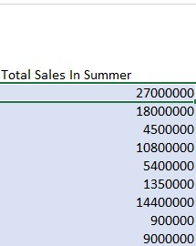=((E9*F9) *30) *6

1. **Calculate the total Sales of each product of a whole year**

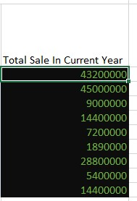**Solution: Query Which will be used is:**

**=SUM (D9:E9)**

1. **Calculate the Total Sales of Winters and Summers and Compare which season is profitable Solution:**

1. **calculating total sales of winter:**

**==SUM (G9:G17)**

1. **calculating total sales of summer:**

**==SUM (H9:H17)**

**c)Finding which season has most sales:**

**=MAX (E28:F28)**



5) Calculate which is the most sold product of summer and winter Solution:

1. calculating the most sold product of winter:

=MAX (G9:G17)

1. calculating the most sold product of summer:

=MAX (H9:H17)

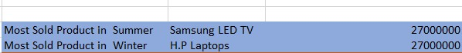

6)Calculate the number of products Sold in a year Specific price range:

1. Within 1 Lakh
2. Range of 1 Lakh -10Lakh

c)Range of 10Lakh -1 Cr

d)above 1Cr

Solution: Query that will be used are:

* 1. For Products sale within 1Lakh

=COUNTIF (I9:I17,” <100000”)

* 1. For Products Sale Ranging 1 Lakh to 10 Lakh:

=COUNTIFS (I9:I7,”>100000”, I9:I17,” <1000000”)

* 1. For Products Sale Ranging 10 Lakh to 1 Cr:

=COUNTIFS (I9:I17,”>1000000”, I9:I17,” <10000000”)

* 1. For Products Sale More than 1Cr:

=COUNTIF (I9:I17,”>10000000”)

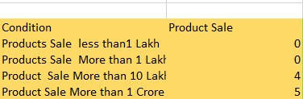OUTPUT:

7)Calculate the most and the least sold product in the whole year?

Solution: Queary to Find these are:

a) The most sold Product in whole year: =MAX (I9:I17)

B) The least sold Product in whole year:

=MIN (I9:I17)

OUTPUT:

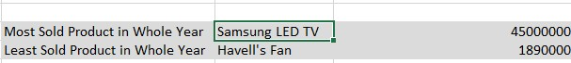

8)Compare the Total Sales of Current year with the Total

Sales of Previous year

Solution: Query to Find this is:

1. Calculating the Total Sales of current year:

=SUM (I9:I17)

1. Finding The most Profitable Year either Current or Previous:

=MAX (E30:F30)

Output





9)Calculate the Least Sold Product in Summer and Winter?

Solution: Query to Find These are: a) Least Sold Product in Winter:

=MIN (G9:G17)

b) Lease Sold Product in Summer:

=MIN (H9:H17)

Output

10)Using VLOOKUP Find the Base Price of the Following Product:

1. H.P Laptop
2. Havel’s Fan

c)Samsung Fridge

d)Samsung Mobile

Solution: Query that will be used here are:

1. H.P Laptop:

=VLOOKUP (B10, B9:I17,5, FALSE)

1. Havel’s Fan:

=VLOOKUP (B14, B9:I17,5, FALSE)

c)Samsung Fridge:

=VLOOKUP (B17, B9:I17,5, FALSE)

d)Samsung Mobile:

=VLOOKUP (B15, B9:I17,5, FALSE)

OUTPUT:

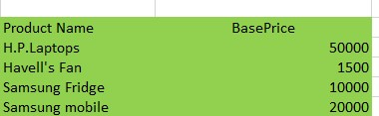

## CONCLUSION

The **Electronics Sales Management** table served as a comprehensive resource for analysing seasonal and annual sales trends across a wide range of electronic products. Through our case studies, we gained valuable insights into product performance, pricing distribution, and seasonal profitability.

1. By calculating the **total sales of each product in both winter and summer seasons**, we identified fluctuations in consumer demand. Cooling products like **air conditioners** and **coolers** dominated summer sales, while **heating appliances** and entertainment products like **room heaters** and **LED TVs** saw higher sales during the winter season.
2. The calculation of **yearly total sales for each product** helped us evaluate overall product performance and market popularity across all categories.
3. Comparing **total sales between seasons**, we determined which season was more profitable overall, providing critical insights for future inventory and promotional strategies.
4. Identifying the **most sold product in both summer and winter** gave clarity on seasonal customer preferences and highlighted best-performing items that drive revenue.
5. We classified the number of products sold within specific **price brackets**: oProducts sold **within ₹1 Lakh** oBetween **₹1 Lakh – ₹10 Lakhs** o From **₹10 Lakhs – ₹1 Crore** o And **above ₹1 Crore**

This helped us understand the impact of pricing on buying behaviour.

1. The table also helped determine the **most and least sold**

**products in the entire year**, which provided insight into which items need focus for promotion or reconsideration in stock planning.

1. The study of **least sold products in both summer and winter** offered a clear picture of underperforming items during specific seasons.
2. The **year-over-year sales comparison** gave a useful overview of our growth or decline, revealing how our sales this year matched up against last year's performance.
3. Lastly, by applying the **VLOOKUP function**, we were able to quickly find the **base prices** of important products such as the **H.P Laptop, Havel’s Fan, Samsung Fridge, and Samsung Mobile**, demonstrating how efficiently data can be retrieved from a large table using Excel functions.

**Final Remark:**

Overall, this table and the case studies helped us draw meaningful conclusions about product trends, seasonal demands, pricing strategy, and annual performance. It has enabled better strategic decisionmaking for future planning, inventory management, and sales forecasting in the electronics retail business.